How to Access Online Accounts for the Baltimore County Public Library

- Go to www.bcpl.info

- Click on the “Account” tab along the top of the webpage.

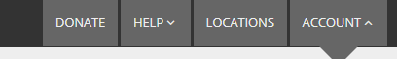

- Click on “Log In Now”
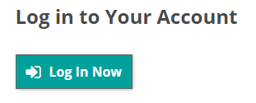
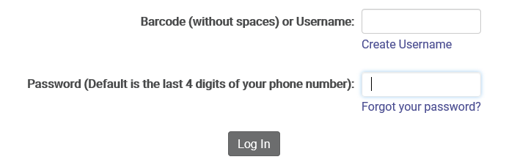
- Enter the “Username” and “Password” in the text boxes provided and click “Log In”. (The Username that students will use is their BCPS Student ID# and this information will be given to each student through their Homeroom Teacher). The password for all students will be 0000.

0000

- After successfully logging in, you will be taken to the main dashboard login screen shown below.
