How to Access The OverDrive Database To Check Out E-Books
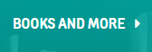
- Once you have logged into your BCPL account, click on “BOOKS AND MORE” at the top of the screen.

- Click on “DOWNLOADABLES” from the dropdown menu.

- Click on the “OverDrive” database link.
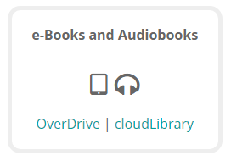

- Click on the “Sign IN” button at the top of the screen.
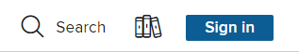

- Select Baltimore County Public Library (1) from the dropdown menu and enter your BCPS Student ID# (2) in the box that says CARD NUMBER. Click Sign In (3).
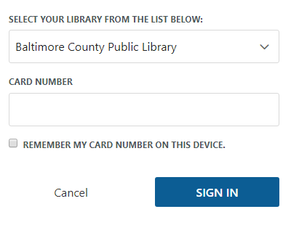
1

2

3

- Click on KIDS or TEENS on the top menu bar to view the available eBooks and Audiobooks.
- Click on BORROW to check out an available eBook.

How To Access E-Books You Have Checked Out and Begin Reading Them
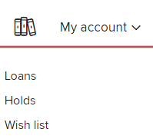
- While in OverDrive, click on “My Account” in the upper right hand corner and select “Loans”.

- Find the E-book you want to begin reading and click “Read now in browser”.
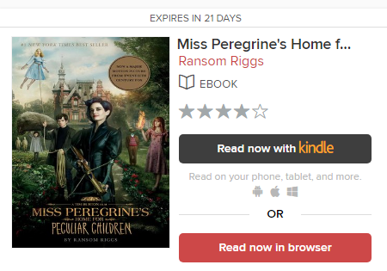

- If you finish a book or decide you no longer want to continue reading it, you can remove it from your account at any time by clicking on the “Return” button at the bottom of the book.
